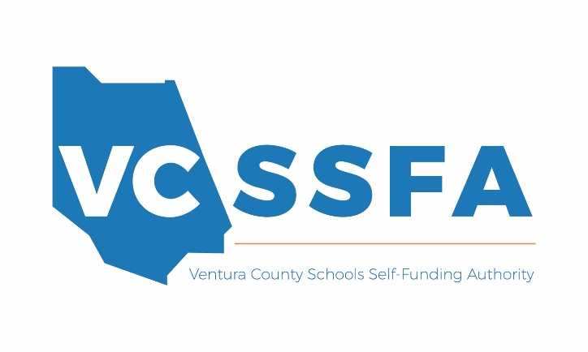
Types of Agreements
Information Sheet
The following list can help districts Local Educational Agencies decide which type of Agreement Memorandum of Understanding (MOU) or Contract should be used.
- [Short Form] Services Agreement
  - This agreement is intended to be used for low-cost, low-risk, short-term services.
  - Examples:
    - Animal demonstrations
    - Disk jockeys
    - Enrichment programs
    - Event planners
    - Food vendors
    - Inflatable Amusement Devices
    - Office equipment repair
    - Story Tellers
    - Other student assembly activities
- [Model] Services Agreement
  - This agreement is intended to be used for higher-cost, higher-risk services.
  - Examples:
    - After-school programs
    - Higher-risk field trips and activities
    - Maintenance and repair projects, small construction, remodel, or modernization projects
      - Carpentry
      - Drywall
      - Electrical work
      - Heating ventilation and air conditioning (HVAC)
      - Landscaping
      - Painting
      - Plumbing
      - Roofing
      - Welding and cutting
    - Canine search
    - On-campus medical services and clinics
    - Playground installation
    - Professional services
    - Transportation Network Companies
      - Hop Skip Drive
      - Zum
- Specialized Memorandum of Understanding
  - An MOU is to be used for low- or no-cost, significant risk, agreements.
  - Examples:
    - Charter Schools
    - Agreements with other government agencies
      - Ventura County Health Care Agency
    - Interns, externs, and/or job shadow programs
    - Student services contracted by parents
- Specialized Contract
  - Large construction or modernization projects
  - Transportation Agreements
  - Asbestos or asbestos-containing materials or lead-based products removal
  - Concrete, masonry, plaster, stucco (silica-based materials) cutting, drilling, grinding or removing
  - Educational computer applications, web-based services
    - Standard Student Privacy Agreement (needs indemnification and insurance requirements)

